Classical Interactive Program

* Changing state
* Changing display
* Keyboard and/or mouse affects behavior

Domain information

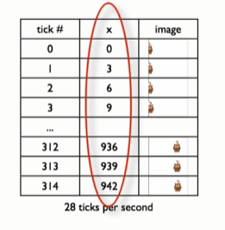

Data definition

* To tell us what x mean/represent

